**Base Class Theology: An Introduction to Pantheism**

This is a class structure reduction of theology based on how theology is produced and what it’s for. By class structure I mean in computer science logic, where the objects “Orange” and “Apple” which extending from “Fruit”, can be used to deduce the properties of that abstract parent class “Fruit”, even without direct access to the class1. Nature is the objective base class, but how that is conceptualized becomes religion. This is about that process.

Tesla, a Pantheist2, credits a lot of his insight to a reduction between Christianity and Buddhism3. The overwhelming majority of true genii engage in ideation and categorization of meta forces down to the personal level, and Tesla mastered his understanding of a fundamental force as a result. Most people who have experienced the both of these popular but contrasting religions would say there is good insight between them. Theology within nature is a means to categorize thought and actions according to the results they produce for society, people, and the environment.

All theology, like philosophy and science, are derived from the same empirical reality.

The universe is one thing, and form evolves within it.

An individual object is recognition in the mind of a single unit of form; a flower, the moon, a country, a meme, where the division of that thing from the rest of the universe is the scope of attention to that thing.

Scope from everything down to an individual unit or form allows the comparison of how it operates relative to the surrounding universe in terms of it having a relative *gain* or *loss*, and whether or not that gain or loss is *sustainable* or *not* to the surrounding ecosystem of forms. This is the fundamental way in which good and bad are sorted.

Punnett square between *positivity* and *sustainability:*

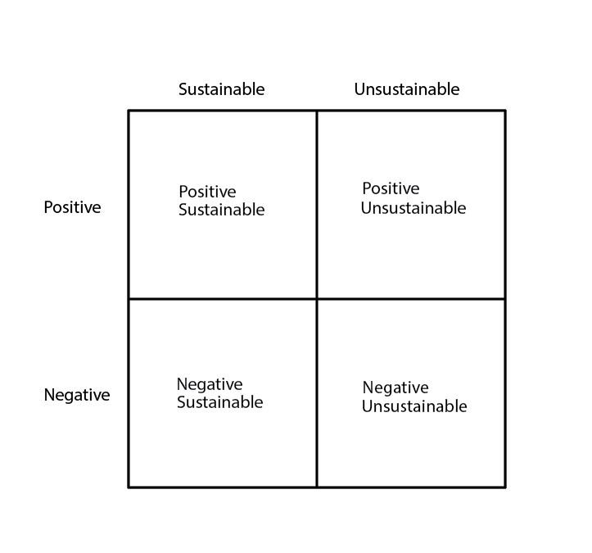

The *entire* taxonomic tree of life extends from matter and energy interacting in a way which conforms to the systems dynamics principle of a *positive and sustainable* system, for its scope, relative to the environment. It is the principle which allowed for abiogenesis, and also the logic which governs life in terms of which decisions are good. Therefor in principle it is the creator, and the law giver of lore, the ideation of this force as a being –doing so engages the default mode network with the heuristic; they wire together. Pure sin is recognized as things which do harm or cause pain, that damage the doer and the surrounding forms. Forms which slip away from positive and sustainable lose order and are consumed by chaos. The taxonomic tree fractal, in this context, is the burning bush, where the fire is a negative unsustainable symptom of chaotic breakdown. When you love yourself, or someone else, you engage in rationality over what is good for them and what sustains their life, and this is the force of God playing out in people’s lives according to how they choose to live, because of what they attach to those inwardly instantiated beings. So Pantheism is like nature worship meets monotheism with the scientific method, and this allows you to unite the fields into one. Many things can be mapped using this pattern.

Any object, as its functional structure produces behavior, will fall into one or move between categories as time passes. For example, the rise and fall of empires starting with some *positive sustainable* society, which finds some new power, becoming *positive but unsustainable*, plateauing against environmental conditions and moving to *negative sustainability*, and then collapsing into *negative unsustainability*. This is also why the loss and recovery of the principles of religion go hand in hand with the rise and fall of empires. Or individual people.

The utility of *personification* of these principles into deities, for example: *positive sustainable* into the Christian “Jesus”, and *negative unsustainable* into the Buddhist “Mara”, is that personification engages the *default mode network* which is responsible for *entity processing4*. While you could categorize yourself as a person overall by this heuristic, the sub components of your overall mind/body are child objects which can then be categorized themselves. You can categorize your own individual thoughts and behaviors, and by proxy the substrative brain networks, by using emotional association to upregulate or downregulate the propagation of that network. Interesting how many of the most famous scientists has gotten to some version of it. That being said, the topic of Pantheism is nebulous, and so this is an attempt at structure between theology and science in application terms.

This underlying thought process makes the concept of God tangible to Atheists, because God in the Pantheist sense is simply the personification of something which is readily observable. “Atheism” is commonly confused with anti-religion. Many Atheists finds their way back to positive and sustainable systems, which is commonly “God” to Pantheists anyway. It’s also relevant to all faiths which attempt to define behavior in terms of what enforces or diminishes life.

In conclusion the thought process of base class theology could be useful for joining people of different belief systems. Pantheism5 is appropriate for technocratic culture built on science, which has just as much need for spiritual ideation as it does respect for nature. Now that we have the ability to speculate about what is going on with brain networks given the projection of consciousness onto these ideations of what is good or not, perhaps it’s time to give science the strength of spirit, and religions which don’t have the clarity of modern science a rest. All faiths have some truth in them, and are worth preserving, but pantheism is number one in terms of your own intellectual disposition given science as a value. Buddhism is probably a close second. Then the rest.

1. <https://en.wikipedia.org/wiki/Object-oriented_programming>
2. <https://en.wikipedia.org/wiki/List_of_pantheists>
3. <https://en.wikipedia.org/wiki/Nikola_Tesla>
4. <https://en.wikipedia.org/wiki/Default_mode_network#Function>
5. <https://en.wikipedia.org/wiki/Pantheism>